**Simulation Lab- 2 Assignment**

1. See the figure below:

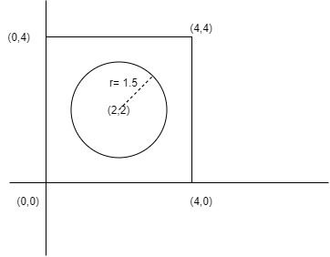

Using Monte Carlo simulation, find the value of PI and area of the circle using the given circle and square. You have to simulate the value for n=100,1000,5000 and 10000 trials. Show the scatter plot, value of PI, value of the area for each value of n. ( Just as shown in the class) .

At the end of the simulation, draw three-bar diagrams.

**First Bar Plot:**  x-axis: number of trials, y-axis: PI -value (Shown in the class)

**Second Bar Plot:**  x-axis: number of trials, y-axis: Error value **[ Error value = abs(estimated pi value - 3.1416) ]**

**Third Bar Plot:** x-axis: number of trials, y-axis: Area of the circle

1. Find the area of the shaded part below using the monte Carlo simulation.

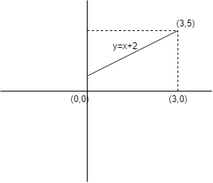

Simulate this area for n=100,1000,5000,10000 trials. For each value of n, print the area and scatter plot.

1. Find the area under the curve below using the monte Carlo simulation. Use the drawn rectangle.

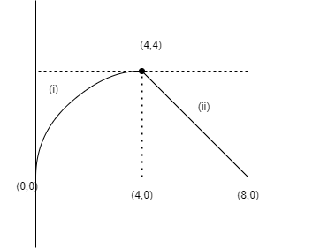

Equation of curve - (i) is : y2 = 4x

Equation of (ii) is: y = 8 - x

Simulate this area for n=100,1000,5000,10000 trials. For each value of n, print the area and scatter plot.